**Shortlisting**

**Following the closing date and shortlisting process, our Recruitment team will be in touch to confirm if you’ve been successful to move to Step 2 of the process.**

**Apprentice Recruitment Steps**

**Application**

**Click ‘Apply Online Now’ to complete an online application.**

**Please make sure you complete your application before 8th April 2024 as we won’t be accepting any further applications following this date.**

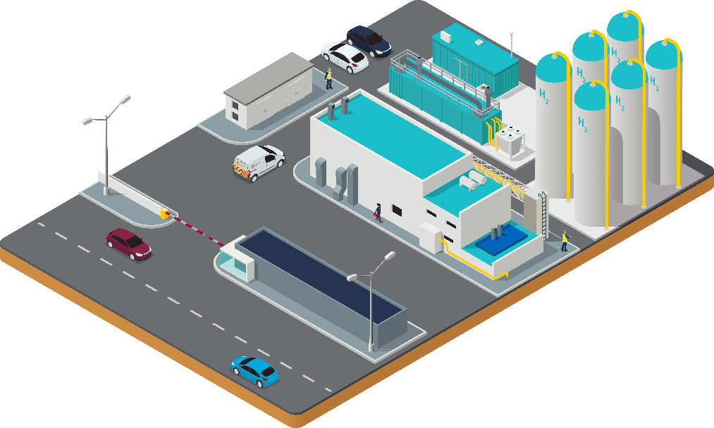

**Assessment Centre**

**If successful in step 1 & 2, you will be invited to attend a one-day assessment centre which is likely to be in Celtic Springs on week commencing 13th May 2024.**

**On the day, you’ll take part in a few exercises including an interview.**

**Selection & Offer**

**If you’re successful at the assessment centre, you’ll receive a conditional offer of employment. Your offer of employment will remain conditional until we’ve completed the following pre-employment checks. These are:**

* **WWU receiving satisfactory references and qualifications**
* **Completion of a satisfactory health assessment, drug and alcohol test and Right to Work in the UK check.**

**Feedback can be given to unsuccessful applicants at any stage of the recruitment process on request.**

**Welcome aboard!**

**This is where your future begins!**

**You’ll attend a full induction programme where you can learn more about our company and the industry we work in.**

**You’ll also get to meet some of the key people you’ll be working with during your apprenticeship. Former apprentices will be on hand to chat about what you can expect as a colleague at Wales & West Utilities and there will be some team activities to help you build relationships with your future colleagues.**